Vintage Hills Elementary

Science Fair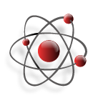 Booklet

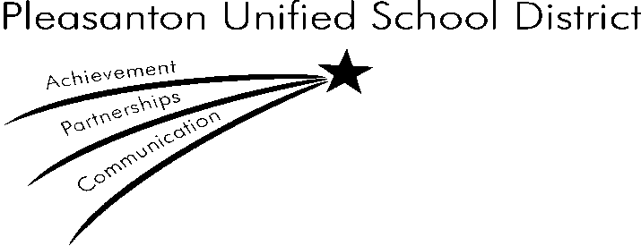

This book belongs to:

j0305257**Science Fair Important Information**

\*\* A fun event to encourage students K through 5th grade to have

fun with Science

\*\* To demonstrate that ‘Science can be fun’.

\*\* To stimulate and nourish a fond interest in Science.

\*\* To promote understanding of and creativity in the

Scientific Method of Investigation.

\*\* To promote self-discipline (character trait) necessary to accomplish

the project.

\*\* To promote science education at all grades by individual presentation

of science projects.

\*\* To give the students a sense of pride and accomplishment derived from

participation.

\*\* To foster a lifelong appreciation of scientific processes in preparation for life

in an increasingly technological society.

**Important Dates to Remember**

**Science Fair Exploration: February 8th 8:00am – 9:00am and 3pm-4:00pm.**

Books will be available in the library to browse and get ideas from. Project boards can be purchased.

**Science Fair: March 22nd, 2016.**

Students will present their projects to interviewers in the morning, 9:00am-11:30am.

*If you are interested in volunteering to interview please contact Diane Degroot via* diane\_degroot@yahoo.com

**Getting Started…**

Your project does not have to be complicated or use expensive materials. In fact, the best projects are simple. Keep it easy and just have fun. Students from the upper grades may use books to find an idea, but are encouraged to modify the experiment to make it an original one. Adults can help with your project if you need it, but they should help as little as possible. Your work should be your own so that you really understand your project.

Use the scientific method if at all possible. Using the scientific method will help prepare you for future scientific studies. Remember too, that ALL types of projects require a display board. The project board should be bright and colorful and clearly show what you have learned. It should contain your school name, your grade, and your name and room number.

The first step in getting started on your project is choosing a topic. Here are some suggestions. The world is full of hundreds of ideas from A to Z.

Science Topics A to Z

A amphibians, animals, archaeology, astronomy

B bats, biology, birds, boats, bones, brain

C chemistry, color, computers, conservation, constellations, caves

D dew, digestive system, dinosaurs, disease, drugs, decomposition

E ear, ecology, electricity, enamel, energy, eye

F fingerprints, fish, flowers, fossils, friction, fruits

G gardening, geology, giraffes, glass, glaciers, gravity

H habitats, heart, herbs, hot-air balloons, human body

I insects, instinct, insulation, invertebrates

J jellyfish, jet propulsion, jet stream, joints

K kaleidoscope, kangaroos, kelp, kidney, knee

L lava, life cycle, lightening, lizards, lung

M machines, magnets, matter, minerals, molecules

N natural resources, nervous system, nutrition

O oceanography, optical illusion, osmosis

P paleontology, petroleum, plants, pollution

Q quail, quartz, quasar, queen bee, quicksand

R rain forest, reptiles, respiratory system, robots, rocks

S soap, solar power, sound, spiders, springs, sundial

T teeth, telescope, terrarium, turtles

U ulcers, unicycles, Uranus

V vertebrates, vitamins, vocal cords

MCj03519680000[1]W water, weathers, work, worms

X x-rays, xylophone

Y yams, yeast, yogurt

Z zebras, zinnias, zucchini



**Science Fair Project Research**

**Finding things at the public library**

Science books, including books about science fair projects, are generally on shelves found in the 500’s and 600’s. Some examples…

J502.8 – J507.8 How to do a science fair project

J500.507, J520 – 523 Space, Universe, Astronomy experiments

J530-J533 – J538 Physics, Sound, Color, Electricity, Magnets

J542 Chemistry and Volcanoes

J550-J552 Earth Science, Rocks, Fossils

J582.16-J595.7 Plants and Trees, Zoology, Insects & Spiders

J612 – J612.3 Human body, Food and Nutrition

J621 Machines and Electronics

J635.986 Gardening experiments

|  |
| --- |
| **Pleasanton Public Library 462-3535**  **12:00 a.m. – 9:00 p.m. Monday and Tuesday**  **10:00 a.m. – 9:00 p.m. Wednesday and Thursday**  **10:00 a.m. – 5:00 p.m. Friday and Saturday**  **1:00 p.m. – 5:00 p.m. Sunday** |

Can’t come in to the library? Stuck on a question after the library’s closed? Contact an online librarian! At the library’s web page, click on Information Resources, then click the Ask Now link, or go to [www.asknow.org](http://www.asknow.org). Just type your question and you’ll be able to “talk” live to a reference librarian, who is also an internet expert. Children are always welcome!

**Websites:**

There are many good sites out there. Here are a few suggestions…

* [www.lii.org](http://www.lii.org) (Librarians’ index to the Internet, a librarian-evaluated selection of thousands of websites)
* [www.scifair.org](http://www.scifair.org) (A one-stop “everything about science fairs” site by a Dr. John Gudenas, Aurora University)
* [www.kidsclick.org](http://www.kidsclick.org) (A research site especially for kids by librarians at the Ramapo, NY Catskill Library System)
* [www.ipl.org/div/kidspace/browse/mas6000](http://www.ipl.org/div/kidspace/browse/mas6000) (Project links from the Univeristy of Michigan’s Internet Public Library)

**Types of Science Fair Projects**

Your science project may be in of five categories:

Collection, Observation, Model, Experiment, or Invention

1. COLLECTION

A collection study is a fun way to learn the proper names of a lot of objects. It involves collecting the objects, describing them, grouping them, and identifying them by their proper name.

The five senses may be used to describe objects:

Eyes color, shape, sheen

Hands texture, weight, temperature

Ears pitch, rhythm, loudness

Nose odor, strength

Tongue sweet, sour, salty, bitter

Examples of a collection might be leaves, insects, seashells, fossils, rocks, coins, or simple machines.

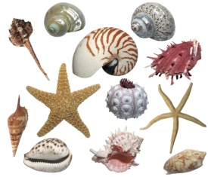

MCj01537120000[1]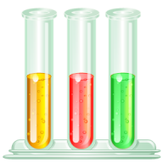

2. OBSERVATION

An observation study begins with the selection of a topic and a question that can be investigated by observing. Specific movements, behaviors, or actions in nature might be observed over a period of time, and once the observations are gathered, they are studied for patterns that will answer the question. Examples of observation might be ants’ eating habits, pollination process, moon phases, family pet behavior or insect lift cycles.

MCBD19716_0000[1]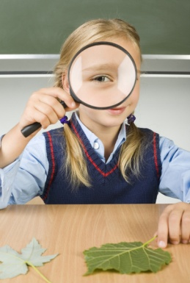

3. MODEL

A model study may begin with a curiosity about how something works. It is a way to display the parts of something and how what each part does to carry out a particular function. Examples of functional models may include building an electromagnet, showing how lungs work, making a solar cooker, or connecting wires to show the difference between parallel and series circuits. Another type of model is an enlargement or reduction as a scaled version of an object. Examples of enlarged-scaled models include building a flower model or a cross-section of an apple. Examples of reduced scale models include making volcanoes, craters on the moon, the solar system, a dinosaur, or a space shuttle.

MCj03981670000[1]

4. EXPERIMENT

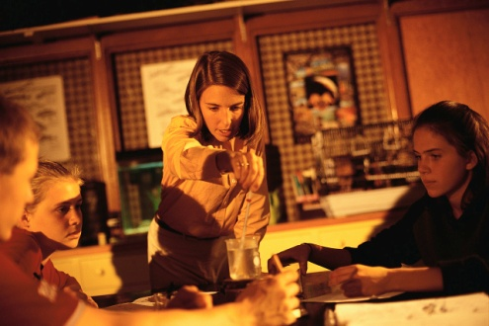 An experiment occurs when one variable (the independent variable) is changed. Another variable (the dependent variable) responds to the first and is watched. Other variables (constant variables) remain the same, or are unchanged, throughout the experiment. An experiment answers a question using the scientific method. Examples of experiments might include ‘How does mold grow on bread and fruit?’, ‘What makes things move?’, ‘How can apples be kept from turning brown?’, ‘What happens when soil washes downhill?’, or ‘How can a person smell what cannot be seen?’

5. INVENTION

j0215086 An invention can be one of two things. First, it can be something or some process that has never been made or done before (for example, the first spaceship, the first car, or the first airplane). The other type of invention is one in which a thing or process is modified in some way (for example, a better television, a better brake system in a car, or a better mousetrap). Such a changed thing or process is still considered an invention. Examples of an invention for the Science Fair might be – design a new toy, make a lunchbox that will keep food fresh for 12 hours, design a new pot for growing plants, make an electromagnet that will pick up 10 nails, or build a bird feeder that will attract only cardinals.

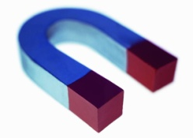

MCj04242060000[1]**The Scientific Method**

**1. SELECT A QUESTION**

You can answer by conducting an experiment. The best science

project comes from a question that YOU want to answer. It is also a good idea to include an

explanation as to why you selected the project.

Your question should be asked in such a way that it couldn’t be answered with a simple yes or

no. For example, “How does salt affect the freezing point of water?” is a better question than

“Does salt affect the freezing point of water?”

**2. FORM A HYPOTHESIS**

This is a guess or prediction about what will happen as a result of your experiment. Forming

a hypothesis will help you design your procedure, and the experiment will prove or disprove

your hypothesis. “I think…” or “I predict…”

**3. PERFORM THE PROCEDURE**

Plan the details of your experiment. Select the manipulated and responding variables. Decide

what things you must keep the same – these are your controls.

1. Determine what you will be measuring and what instrument you will use.
2. Select the materials to form the test equipment. Plan how the tests will be done;

Which test will you do first?

How many tests will you do?

What will be recorded?

How many times will each test be repeated?

1. Assemble the equipment to be used in the experiment.
2. Prepare data sheets for recording measurements and for your comments.
3. As you perform the tests, enter all measurements on your data sheets. It is important that you repeat each test several times.

**4. PREPARE AND EXPLAIN THE RESULTS**

Group and organize the measurements you have made. Make charts, graphs, and tables to

show what happened. It is a good idea to spend some time thinking about your results and

talking to other people about them. Try to explain “how” and “why” the results are what they

are. What was the cause? Do the results agree with your hypothesis?

**5. DRAW CONCULSIONS**

What can you say about your experiment in general? What can you count on happening again

if someone else does a similar experiment? If possible, try to describe how your results might

apply to everyday experiences.

Using these five steps of **SCIENTIFIC METHOD** will make for an orderly experiment

with reliable measurements and results. Follow this, and like any good detective, you

can trust your finding.

**Planning your Science Project**

The Title is \_\_\_\_\_\_\_\_\_\_\_\_\_\_\_\_\_\_\_\_\_\_\_\_\_\_\_\_\_\_\_\_\_\_\_\_\_\_\_\_\_\_\_\_\_\_\_\_\_\_\_\_\_\_\_\_\_\_\_\_\_

My question is \_\_\_\_\_\_\_\_\_\_\_\_\_\_\_\_\_\_\_\_\_\_\_\_\_\_\_\_\_\_\_\_\_\_\_\_\_\_\_\_\_\_\_\_\_\_\_\_\_\_\_\_\_\_\_\_\_\_\_

My hypothesis is \_\_\_\_\_\_\_\_\_\_\_\_\_\_\_\_\_\_\_\_\_\_\_\_\_\_\_\_\_\_\_\_\_\_\_\_\_\_\_\_\_\_\_\_\_\_\_\_\_\_\_\_\_\_\_\_\_

Reference I might use \_\_\_\_\_\_\_\_\_\_\_\_\_\_\_\_\_\_\_\_\_\_\_\_\_\_\_\_\_\_\_\_\_\_\_\_\_\_\_\_\_\_\_\_\_\_\_\_\_\_\_\_\_

Materials I might need \_\_\_\_\_\_\_\_\_\_\_\_\_\_\_\_\_\_\_\_\_\_\_\_\_\_\_\_\_\_\_\_\_\_\_\_\_\_\_\_\_\_\_\_\_\_\_\_\_\_\_\_

Experiment or activity I plan \_\_\_\_\_\_\_\_\_\_\_\_\_\_\_\_\_\_\_\_\_\_\_\_\_\_\_\_\_\_\_\_\_\_\_\_\_\_\_\_\_\_\_\_\_\_\_\_

How I will record results \_\_\_\_\_\_\_\_\_\_\_\_\_\_\_\_\_\_\_\_\_\_\_\_\_\_\_\_\_\_\_\_\_\_\_\_\_\_\_\_\_\_\_\_\_\_\_\_\_\_\_

Imagine what your project will look like. Draw a picture of it and label the parts.